**Laborator 8**

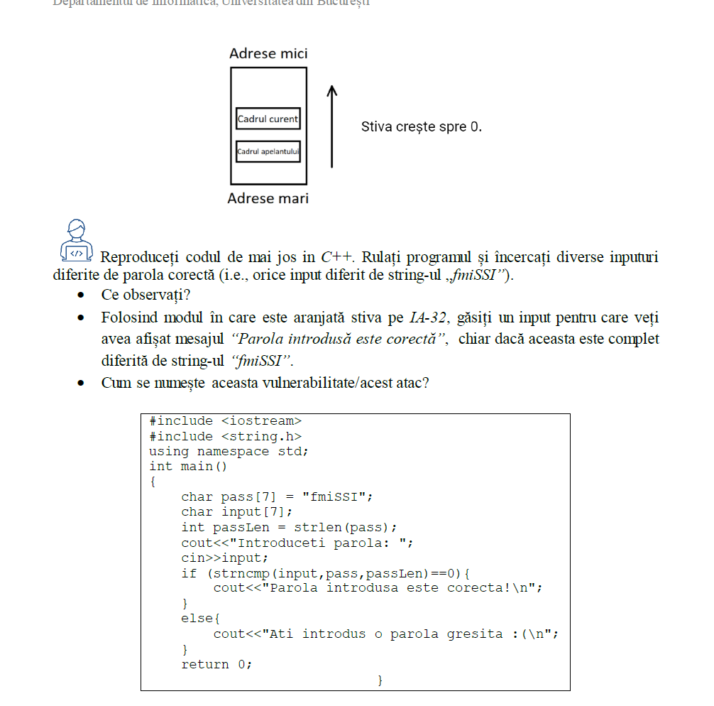2.

2) "XXXXXXfmiSSI"

3) Buffer overflow